**Nicardipine Hydrochloride Injection, USP CONSUMER LEVEL Recall - CUSTOMER CARE TALK TRACK**

**Background Information:** On April 18, 2025, American Regent, Inc. issued a consumer-level recall of Nicardipine Hydrochloride Injection, USP 25 mg/10 mL. This recall was issued due to a product leakage around the neck which could potentially result in a lack of sterility assurance.

This recall affects the following products and lot numbers:

|  |  |  |
| --- | --- | --- |
| **Product Name** | **NDC #** | **Affected Lots** |
| Nicardipine Hydrochloride Injection, USP 25 mg/10 mL Single-Dose Vial | 0517-0735-01 | 24086N0C0 exp. 07/2025,  24076N0C0 exp. 08/2025,  25011N0C0 exp. 06/2026 |
| Nicardipine Hydrochloride Injection, USP 25 mg/10 mL Carton 10 Vials | 0517-0735-10 | 24086N0C0 exp. 07/2025,  24076N0C0 exp. 08/2025,  25011N0C0 exp. 06/2026 |

Further use or distribution of the above-mentioned lots of Nicardipine Hydrochloride Injection, USP should cease immediately.

**Please note:** These products are not carried by the CVS Caremark Mail Service Pharmacies.

** Please ensure to disposition all recall calls to code “**1116**” **

|  |  |  |  |  |  |
| --- | --- | --- | --- | --- | --- |
| **Q#** | **Question** | **Action** | **Answer** | | |
| **1** | **I heard that there is an issue with my medicine, Nicardipine Hydrochloride Injection, USP 25 mg/10 mL. Can you give me more information?** | Note: Check PeopleSafe to determine if the medication is from Mail or Specialty Pharmacy | If the medication was dispensed from… | Then say… | |
| Mail Order | * Yes, I can. * **Proceed to Q2** | |
| Specialty | While in PeopleSafe, determine the phone number of the dispensing Specialty pharmacy and transfer the call.A: Yes, I can. Please hold while I transfer you to your Specialty Pharmacy. | |
| Customer Care/Specialty Talk Track | | | | | |
| **2** | **Why is there a recall? What is wrong with the product?** |  | On April 18, 2025, American Regent, Inc. issued a recall of Nicardipine Hydrochloride Injection, USP 25 mg/10 mL. **This recall was issued due to a product leakage around the neck which could potentially result in a lack of sterility assurance.**  For more information, call American Regent Customer Service at 1-800-645-1706, 8:00 am to 6:00 pm (ET), Monday through Thursday and 8:00 am to 4:00 pm (ET) on Friday. You may also call the United States Food and Drug Administration (FDA) toll-free at 1‑888‑INFO-FDA (1‑888-463-6332) or visit [www.fda.gov](http://www.fda.gov). | | |
| **3** | **May I return the rest of the Nicardipine Hydrochloride Injection, USP 25 mg/10 mL that I have?** | Determine if the patient is affected by this recall | First, let’s determine if you are affected by this recall: | | |
| **If the product was dispensed in…** | | **Then say...** |
| Manufacturer’s Package | | * Check the lot number. The lot number is on the manufacturer’s label on the vial. * If your drug is not from this affected lot number, it is not affected by this recall.   **Please note:** This product is not carried by the CVS Caremark® Mail Service Pharmacies. If you received affected product from CVS Specialty, we will send you replacement product and a postage-paid envelope to return the affected product. If you received any recalled product from your retail pharmacy, please contact the pharmacy that filled your prescription for more information including return instructions.  ***Please note: If the member received recalled product, please submit a damaged bottle reship order and indicate the amount of replacement product to be sent. Please make sure to request call tag.*** |
| **4** | **Should I stop using my Nicardipine Hydrochloride Injection, USP 25 mg/10 mL?** |  | If the medication was dispensed from… | | Then say… |
| Mail Order | | Please hold while I transfer you to one of our Clinical Counseling Clinicians. |
| Specialty | | Please hold while I transfer you to your Specialty Pharmacy. |
| **5** | **Will I receive credit for the product I return?** |  | Your insurance will be credited for any affected product returned to us. We will replace the affected product with unaffected product. You will not be charged any additional copayments. | | |

Additional Information:

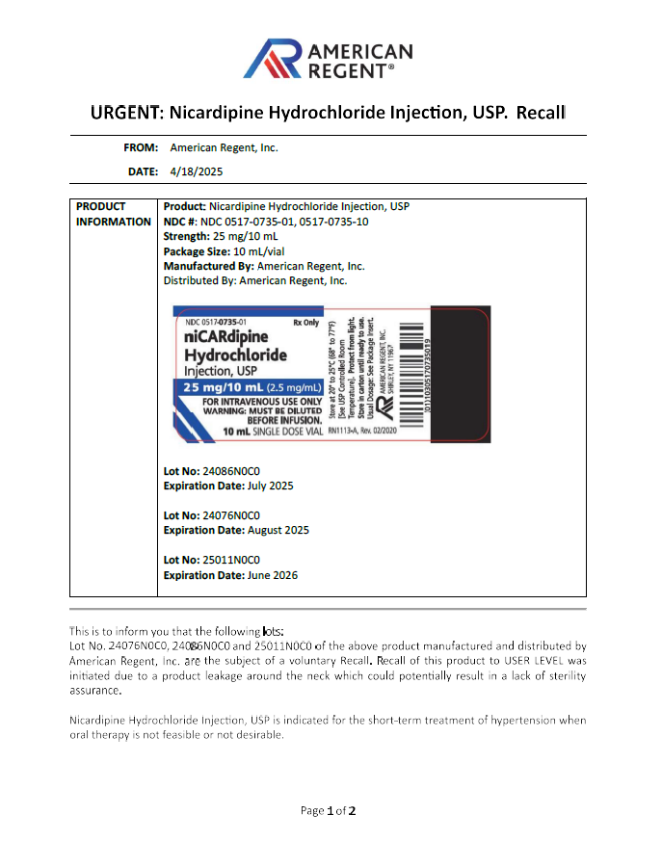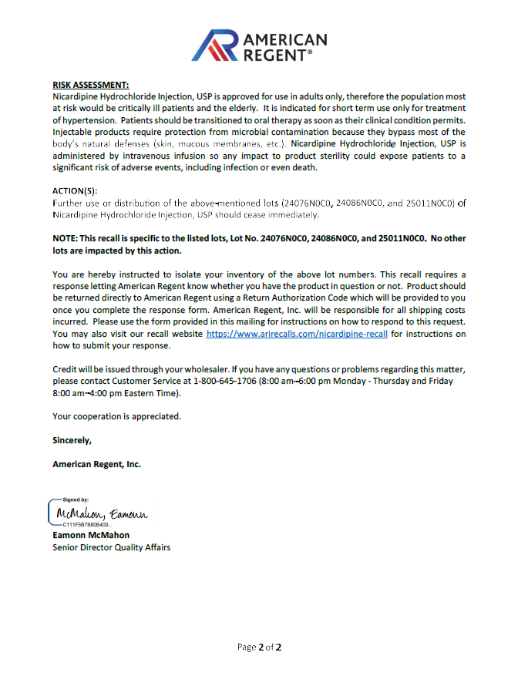

Top of the Document

Not to Be Reproduced or Disclosed to Others without Prior Written Approval

**ELECTRONIC DATA = OFFICIAL VERSION / PAPER COPY = INFORMATIONAL ONLY**